ECEN 325

Lab 10: Characterization of the MOSFET

Section 506

04/17/2020

Jason Gilman

TA: Mandela

**Simulations**

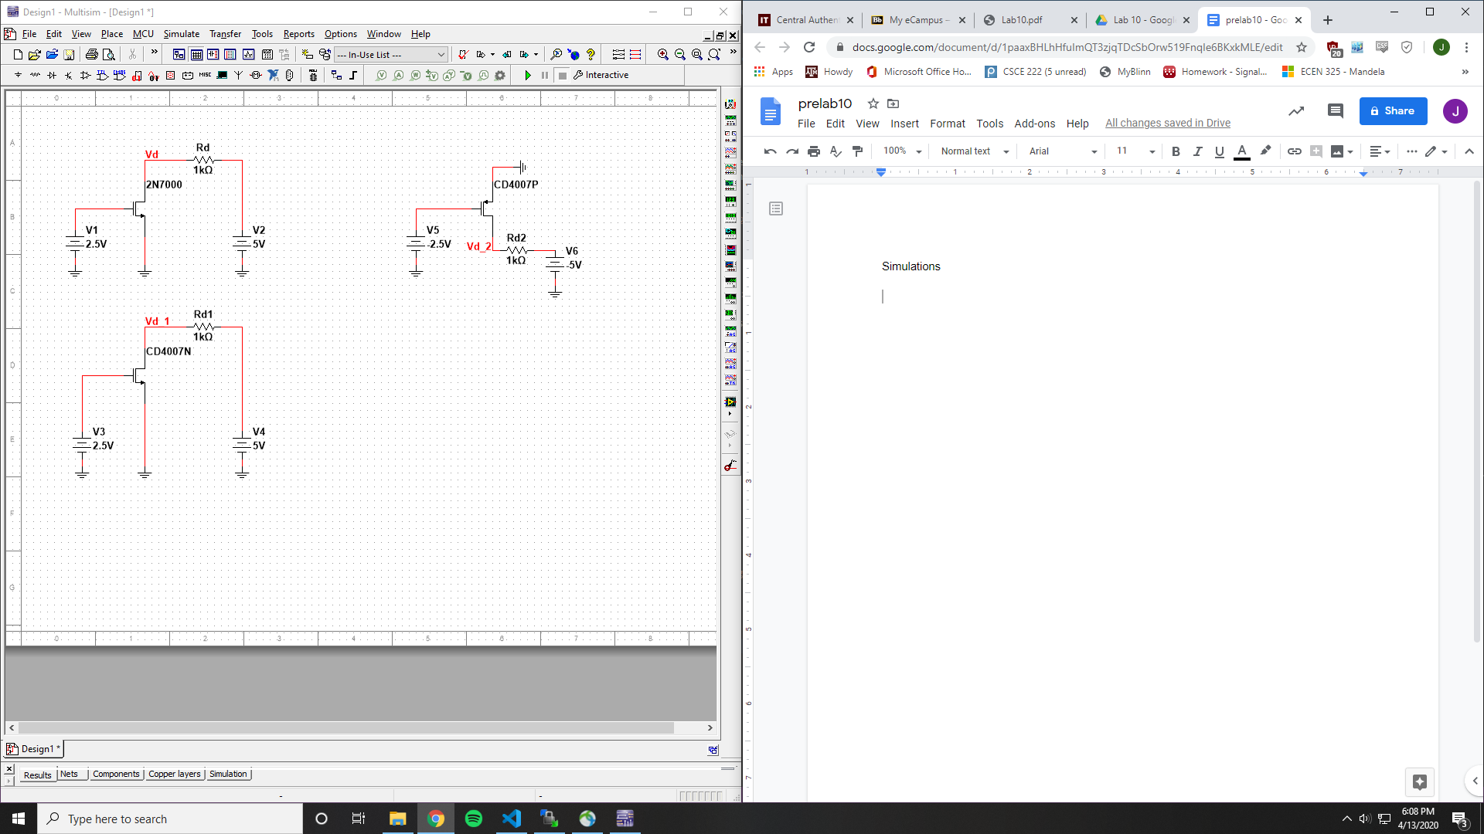

2N7000G

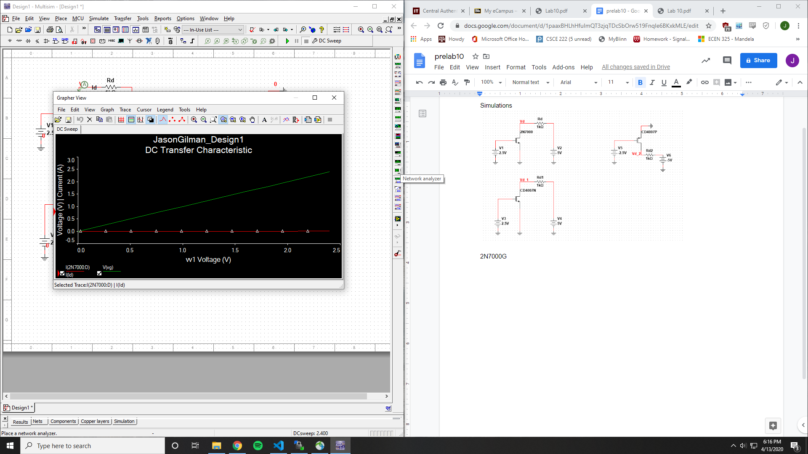

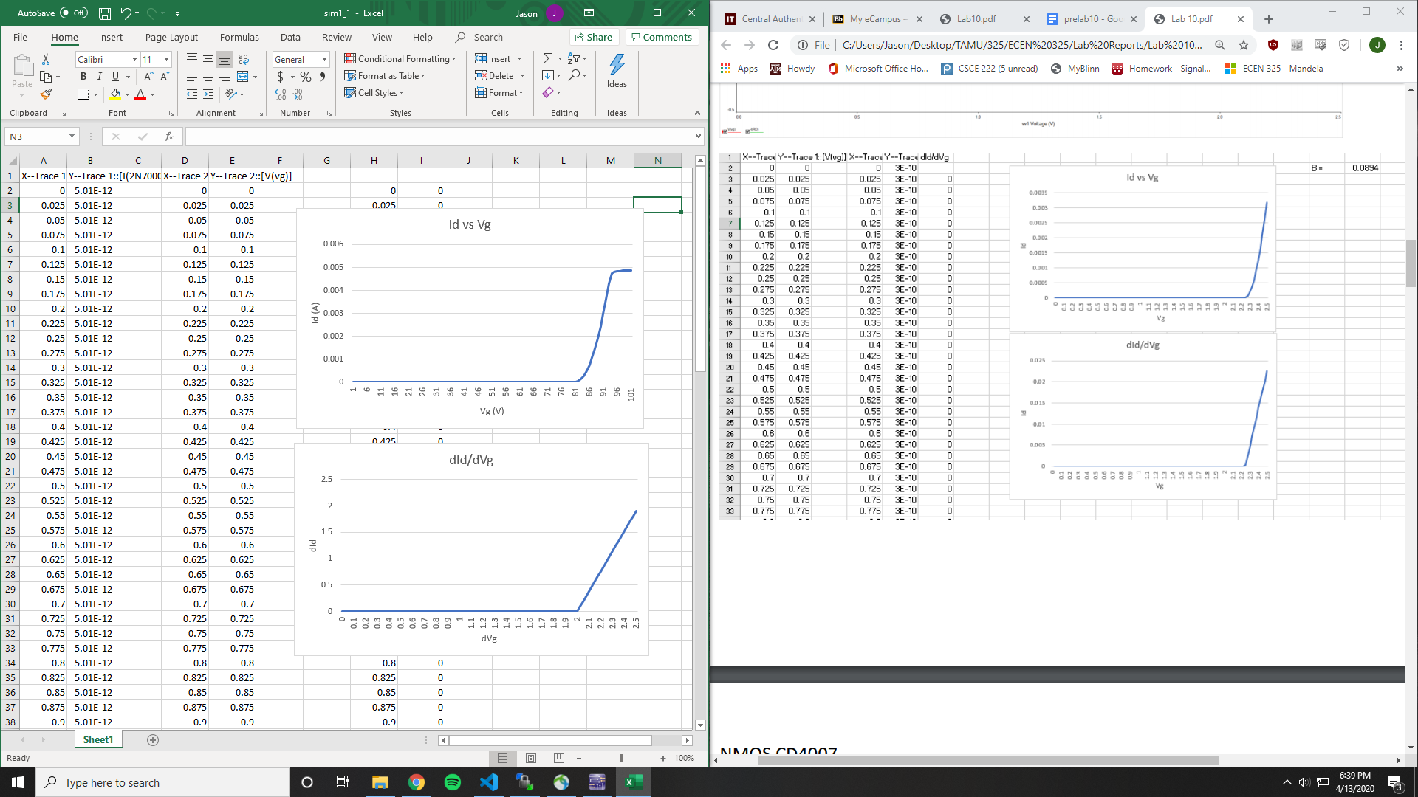

Vt = 2 V

k’W/L = .095464

CD4007N

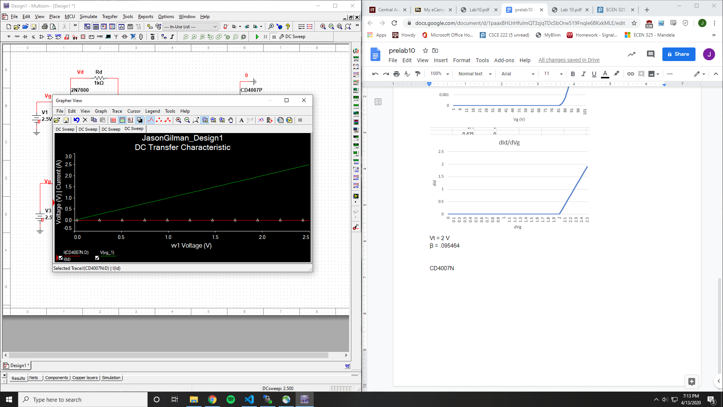

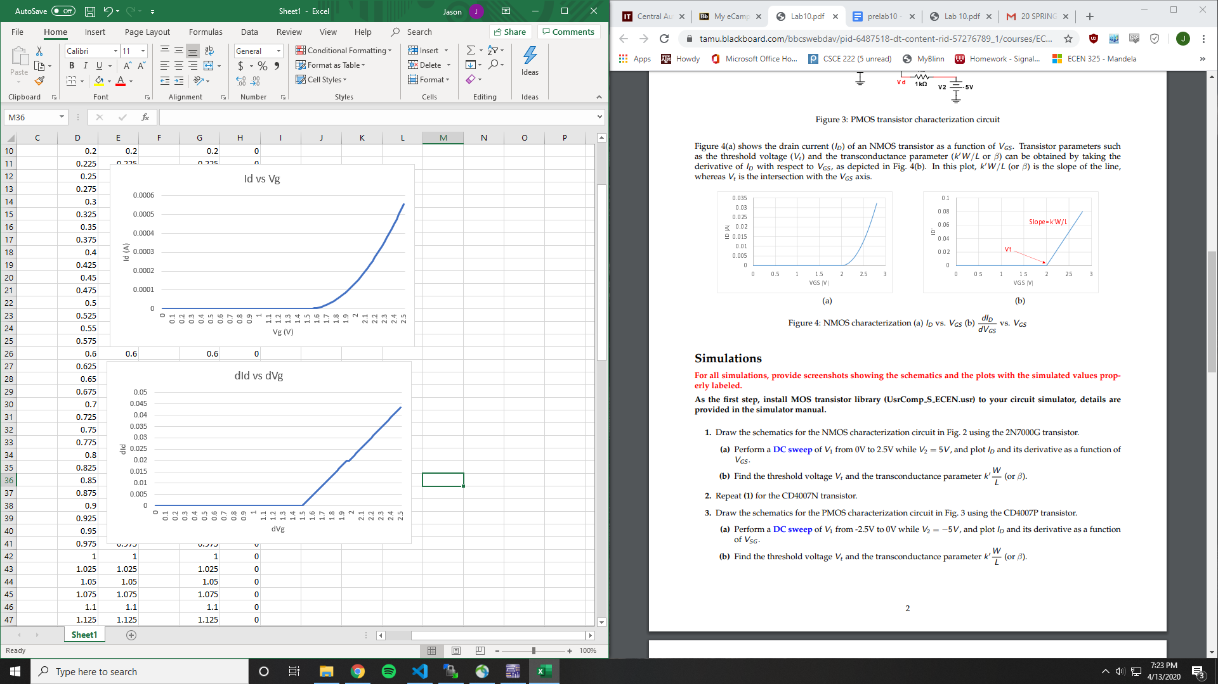

Vt = 1.5

k’W/L = .00111

CD4007P

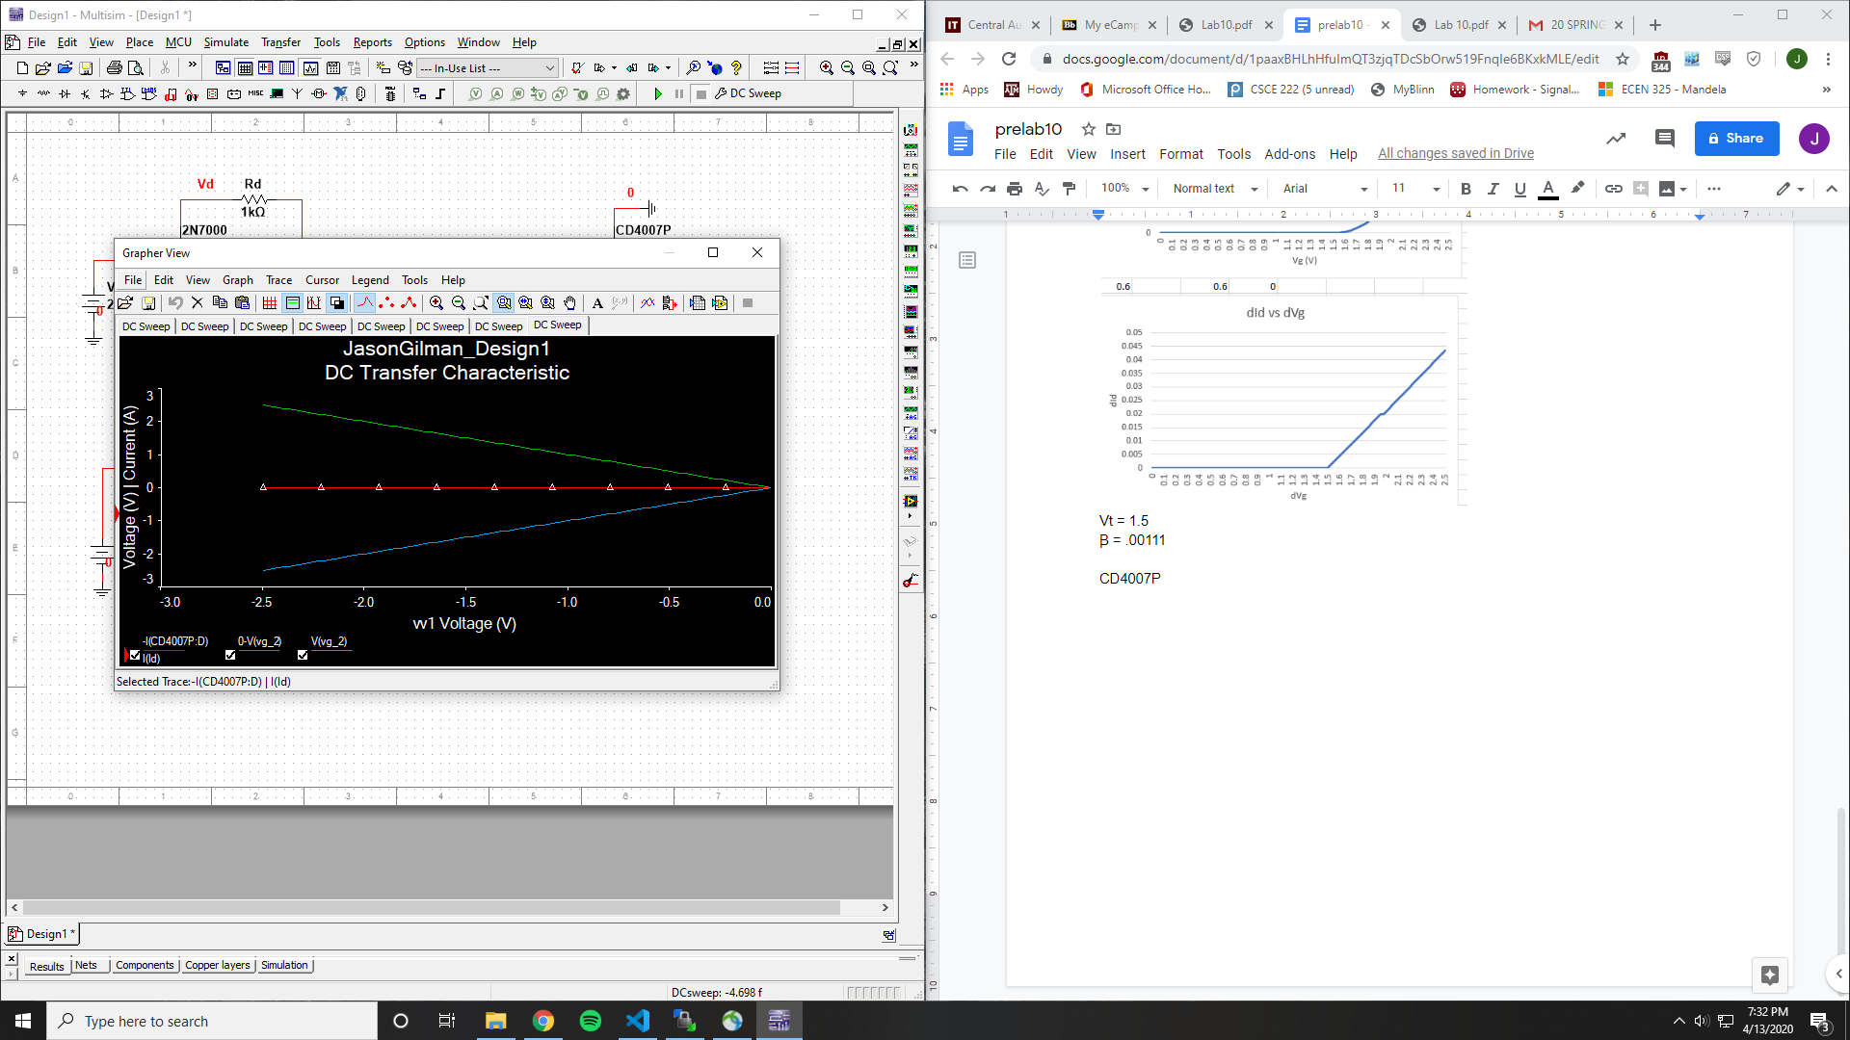

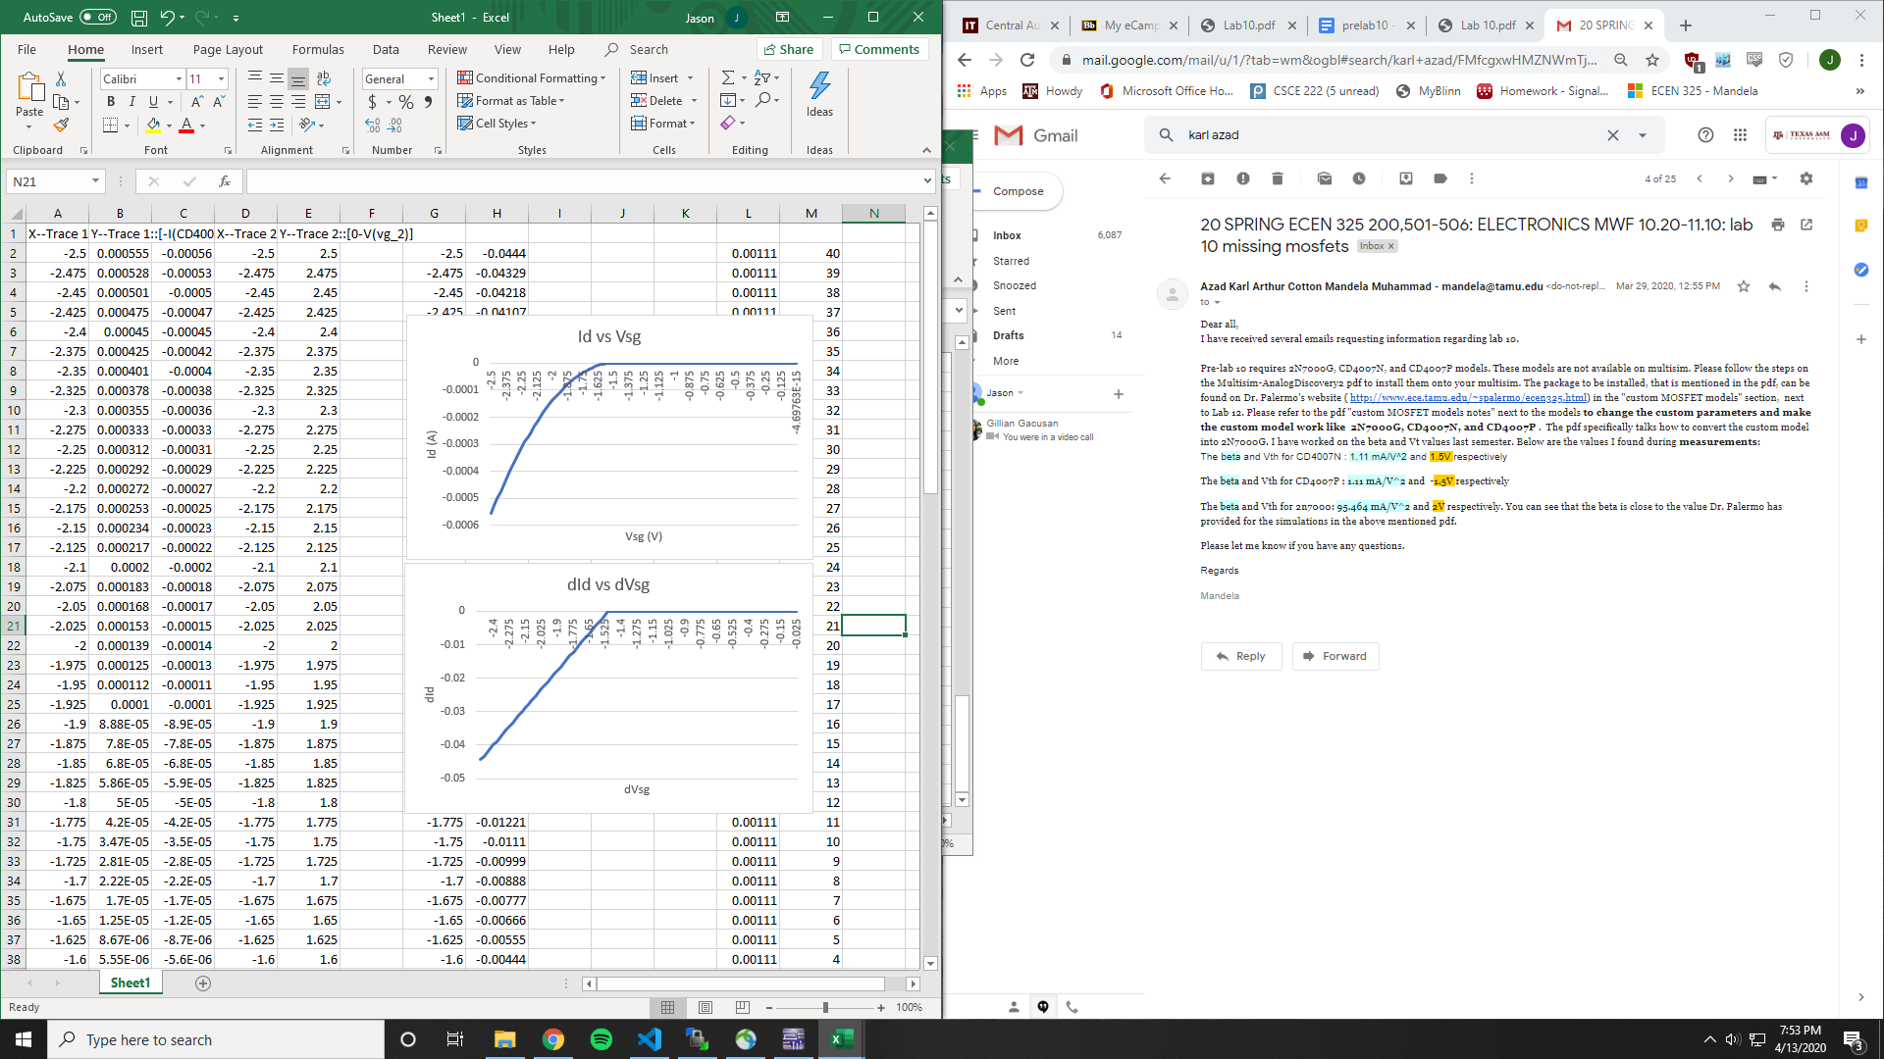

Vt = -1.5 V

k’W/L = .00111

**Measurements**

NMOS 2N7000

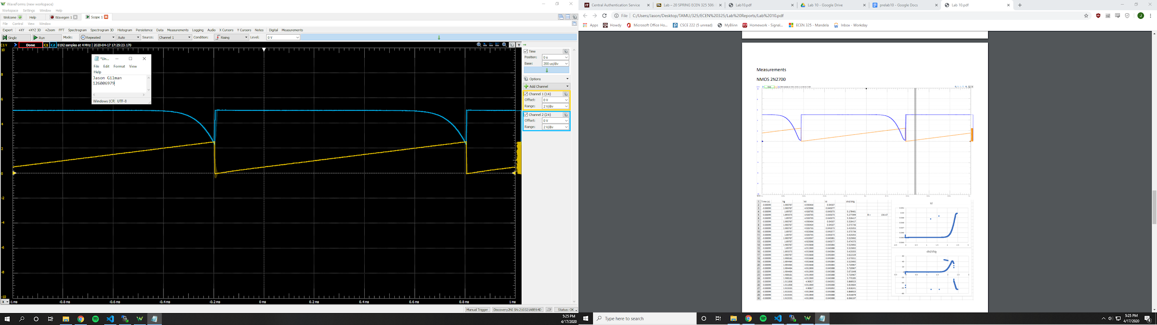

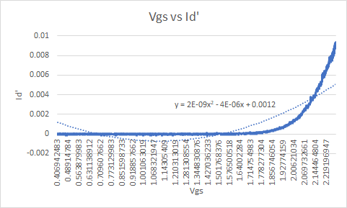

Vt = ~1.778 V

k’W/L = 4e-9

CD4007N

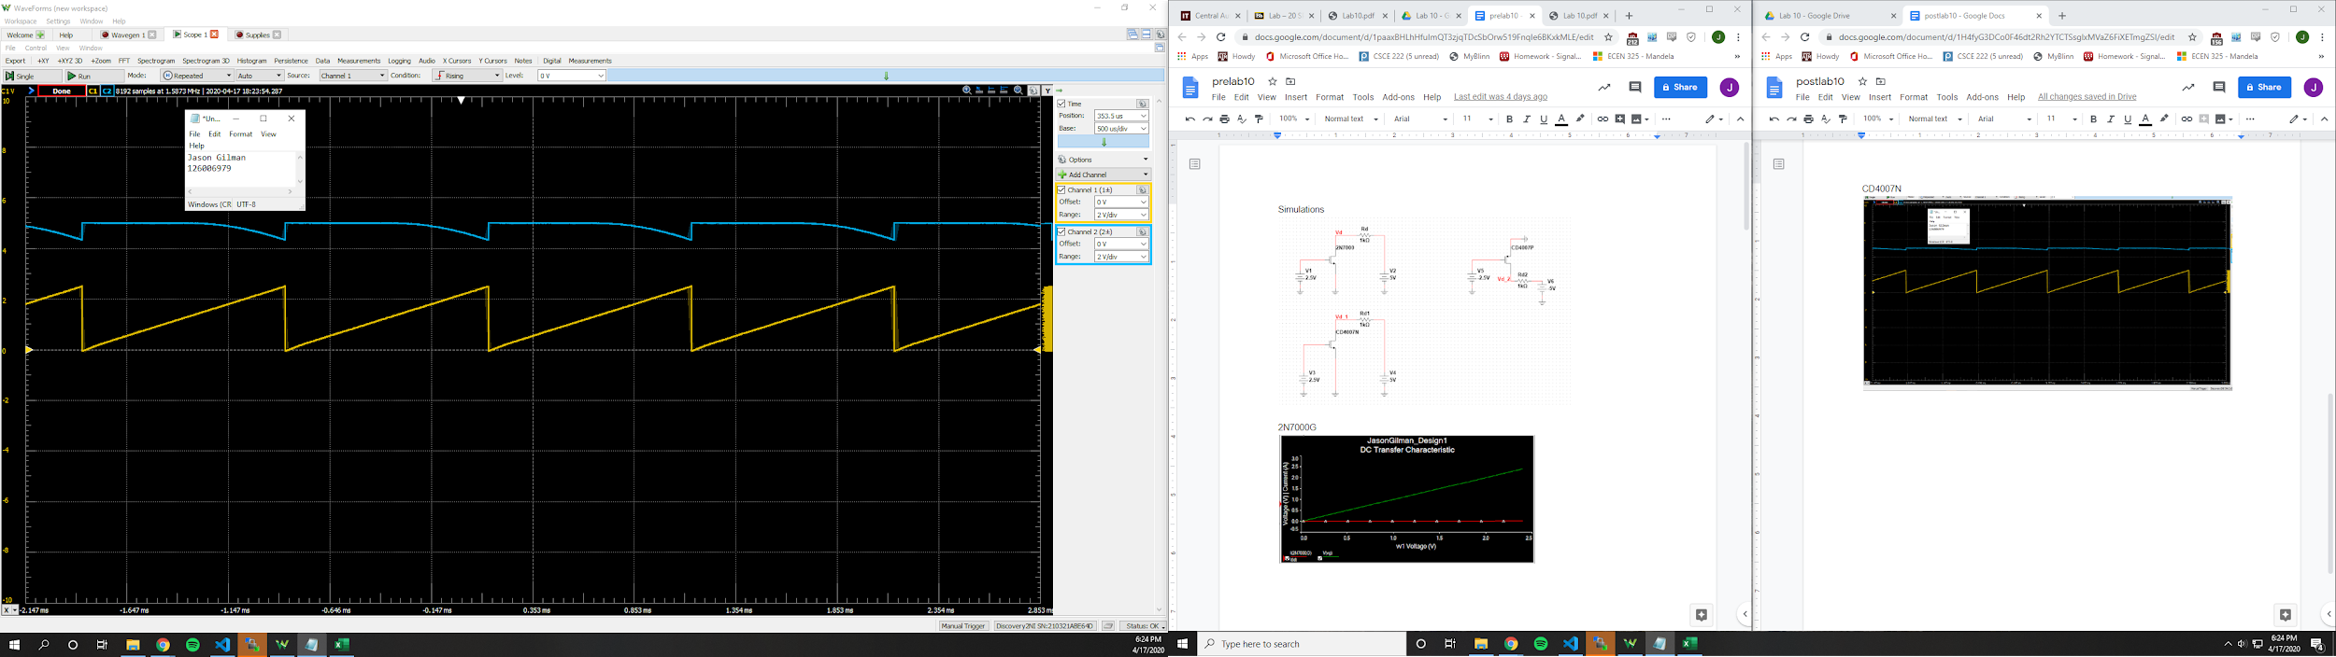

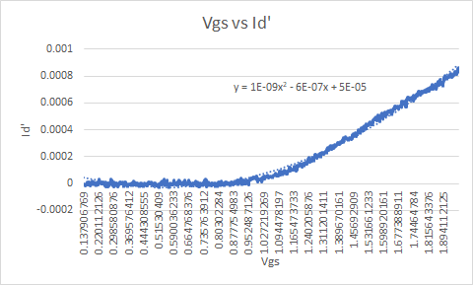

Vt = ~ .95248 V

k’W/L = 2e-9

CD4007P

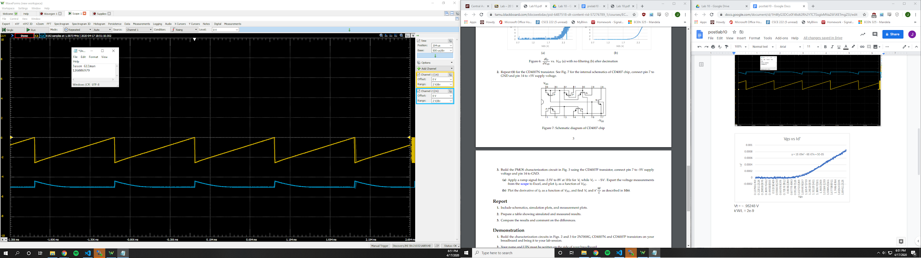

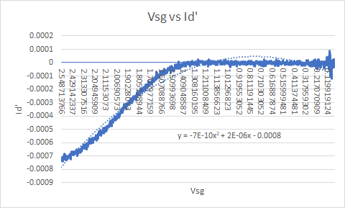

Vt = ~ -1.308 V

k’W/L = 1.4e-9

|  |  |  |
| --- | --- | --- |
|  | **Simulated** | **Measured** |
| **2N7000** |  |  |
| Vt | 2 V | 1.778 V |
| k’W/L | .095464 | 4e-9 |
| **CD4007N** |  |  |
| Vt | 1.5 | .952 V |
| k’W/L | .00111 | 2e-9 |
| **CD4007P** |  |  |
| Vt | -1.5 | -1.308 V |
| k’W/L | .00111 | 1.4e-9 |

**Conclusion**

Looking at the results, the threshold voltage that was found in the simulated results is somewhat reflected in the measurements. The k’W/L is off, this could have been due to errors in measurement or simulation.